KARPOVETS
the newspaper of lyceum named after V. KARPOV IS PUBLISHED FROM MARCH, 2015

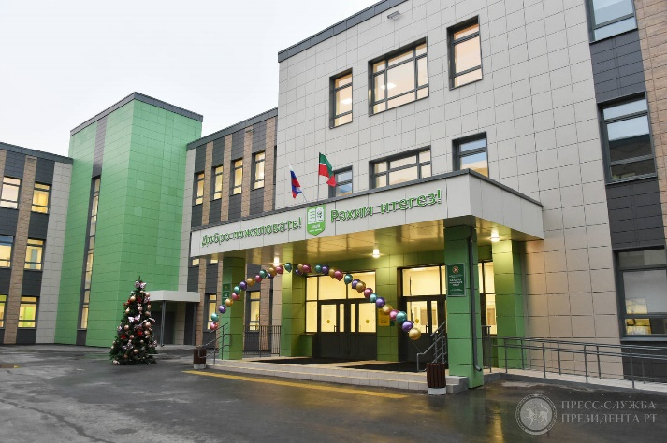Lyceum named after “V. V. Karpov”  Dear Ladies and Gentlemen!  Dear Ladies and Gentlemen! We’re very glad to introduce the 1st issue of “KARPOVETS” we thank all people who took part in the creation of this newspaper. We hope that it is only the beginning and you will like it.  Editors: Nagunanova N.F., Malakhaeva T.A.  Computer design: Malakhaeva T.A.  Articles and interviews: Students of 10A,B grades  Address: st. Gagarin 11A, bl.1 | 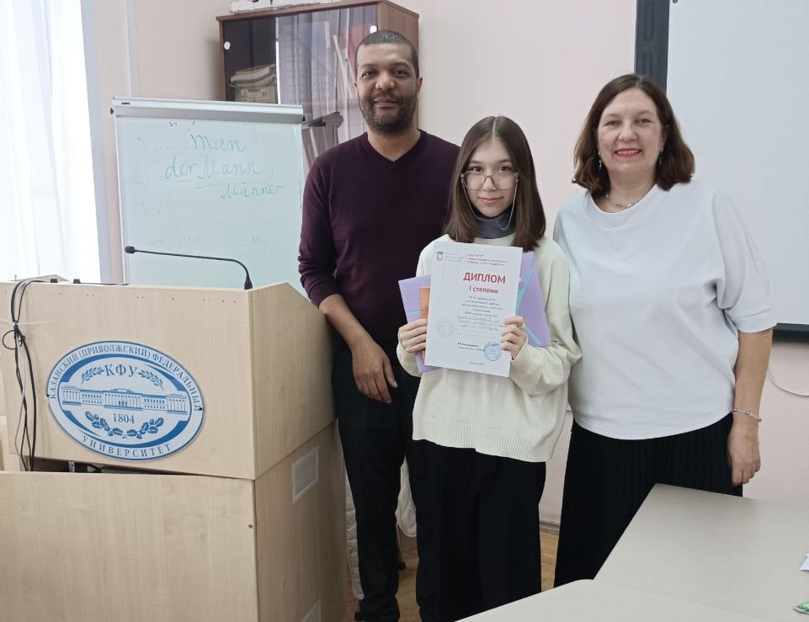  Giniyatova Ramilya, 11B grade  BE ON THE TOP
 | Congratulate us!  Our student - Giniyatova Ramilya (11B grade) has won the first prize for presenting her research work at the Republican Linguistic Forum  “Bridging Languages and Cultures” (on the photo). | However, it was not so easy at first. We’d like to find out more about  her work from her supervisor Elmira Rinatovna Popova (page 4).
In this issue:
let’s smile _{(page 2)} | first attempts at writing _{(page 2, 3)} | interviews with our teachers _{(page 3,4)}
THE HISTORY OF OUR LYSEUM |  | FIRST ATTEMPTS AT WRITING  THE MOST IMPORTANT THING IN LIFE IS WORK  author: PUSHILINA LIZA, 10B GRADE  Work is one of the most important thing in our lives. Some people work on their specialty and love it. Others don’t or can't stand the job. Today we will analyze all its pros and cons.  Firstly, we go to work to earn money. Money provides us with a comfortable life. Work also develops our discipline, sense of responsibility and other abilities. Work always teaches us something new. It has a good effect on our brain and motivates us to live.  On the other hand, work has a lot of difficulties and it is not easy to deal with them. A person gets nervous and exhausted wherefore their health suffers a lot because of this. A job takes plenty of time filling in your whole life. Subsequently a man burned out in his job and slack off it. So work can have a strong impact on us.  To sum up, I think that work is important in our lives and we shouldn't avoid it. You should try to choose the direction that is captivates your mind and try not to be discouraged by failure. If you love what you do, then you won't mind any obstacles.  “The only thing that overcomes hard luck is hard work.”  Harry Golden  
AUTHOR: ALIEVA GYOICHAI, MAMEDOVA AISU, 10B GRADE  The school in the village of Osinovo has a rich history, which began in 1869 with the opening of a private literacy school. Since then, she has repeatedly changed her status:  1884 - Osinovskayazemstvo single-complement literacy school;  1900 -Two-set school;  1918 - reorganization into a primary school;  1932 - primary school was transformed into a seven-year school;  1960 - transition to eight-year education;  1975 - reorganization into Osinovskaya secondary general education school;  1995 - construction of a new school building.  On February 19, 1998, the Resolution of the Cabinet of Ministers of the Republic of Tatarstan Nº 64 was adopted, according to which the Osinovskaya secondary school of the Zelenodolsky district was named after the first director and founder of the state farm "Maysky" - Viktor Vasilyevich Karpov.  On July 14, 2009, a resolution was issued by the IC of the ZMR of the Republic of Tatarstan on the renaming of the municipal educational institution Osinovskaya secondary school named after V.V. Karpov to the municipal general educational institution "Lyceum named after V.V. Karpov" p. Osinovo.  Today, the lyceum is one of the leading schools in the Zelenodolsk district, where 669 students study, including 308 people at the first stage of primary general education, 312 at the second stage of basic general education and 49 at the third stage of secondary (full) general education.  The Lyceum is also a basic school for training tutors who help conduct the USE in computer science and geography. Management of the lyceum: Principle - Koroleva Elvira Narimanovna, head of the highest qualification category, awarded the badge "Honorary Worker of General Education of the Russian Federation". | 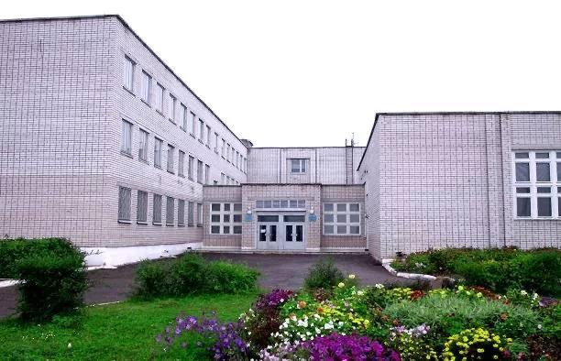  LYCEUM NAMED AFTER V. KARPOV BEFORE 2020  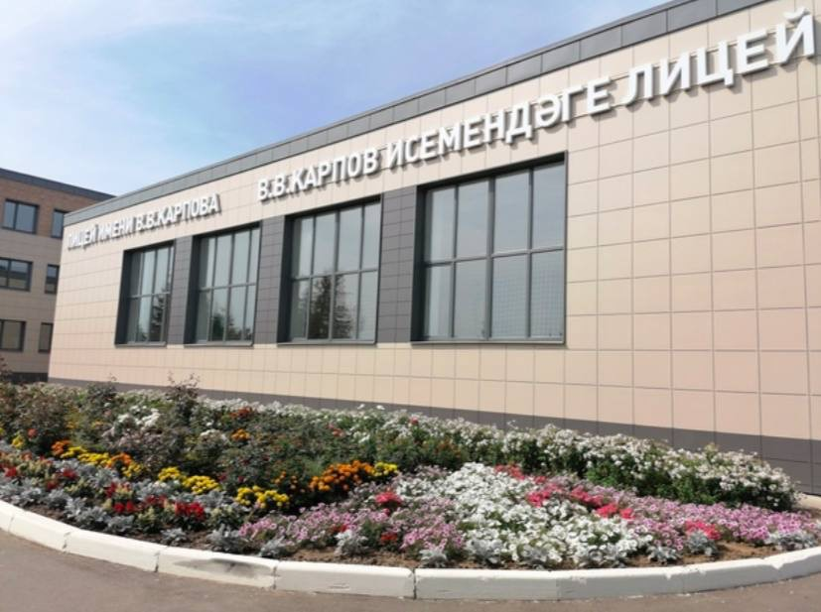  LYCEUM NAMED AFTER “V.V. KARPOV” NOWADAYS  LET’S SMILE  Doctor: “Hello, did you come to see me with an eye problem?”  Patient: “Wow, yes, how can you tell?”  Doctor: “Because you came in through the window instead of the door.”    Teacher: “Why are you late?”  Student: “There was a man who lost a hundred dollar bill.”  Teacher: “That's nice. Were you helping him look for it?”  Student: “No. I was standing on it.”

FIRST ATTEMPTS AT WRITING

WHAT CAN WE DO TO REDUCE LITTER IN OUR CITY?
author: Imasheva Ralina 8b grade  A lot of people don't care about the garbage they have thrown away. They don't mind that our planet is becoming more and more polluted with litter. So what can we do to reduce litter in our city?  To start with, we all should economically use paper, glass, plastic and other materials. It is preferable to avoid buying plastic or paper products. | Instead of this, you can buy fabric bag or thermo-cup and use them every day.  Another way to stop pollution is to join clean-up events. It is important to share your experiences with your friends and people around you. It would be great if more people find out about it and take part too. |  | The great harm to nature is caused by batteries which emit toxins into the air, soil and water. Do not choose the battery-powered electrical appliances.  All in all, there are many ways to reduce litter in our world, but we have to try very hard to keep our home clean.
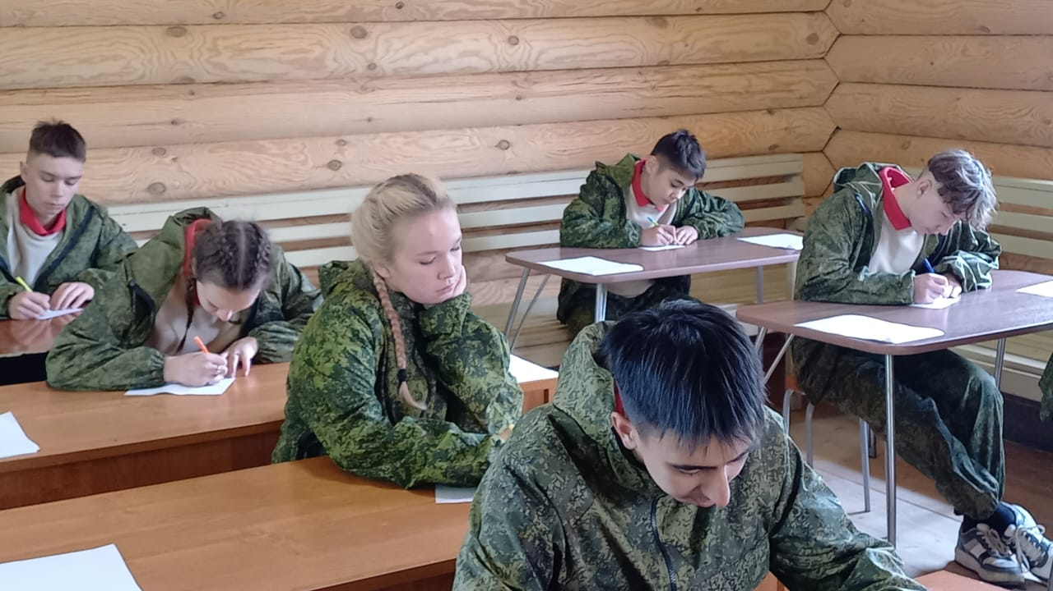  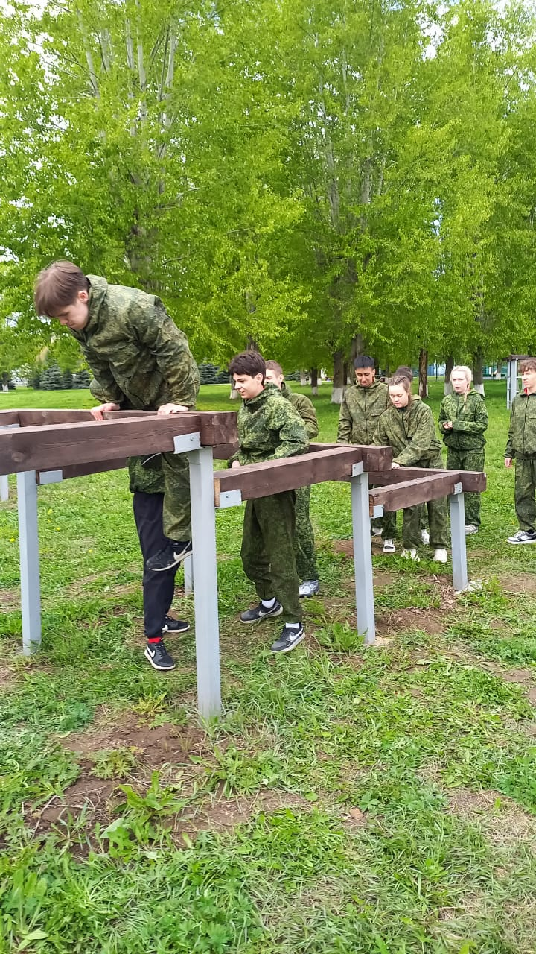 |  | PATRIOTIC EDUCATION IN OUR LYCEUM  authors: Hisamiev Alexey, Smirnov Kirill, 10A grade  Pupils of the Lyceum named after “V. V. Karpov” often take part in events aimed at patriotic education. Such events are held throughout the year, and anyone can participate. The preparation of children is carried out by the teacher of BFSD (ОБЗР) - Nurgaliev Ildus Ravilovich. Let's learn about some of the competitions that are held annually.  • “Zarnitsa 2.0” is an all-Russian military-patriotic game, which includes elements of military tactics, teamwork and physical activity. The aim of the game: acquisition and consolidation of basic military training skills, formation of personal qualities that contribute to the successful self-realisation of young people in work, family and creative spheres. Pupils of our school have been participating in this game for many years and show successful results  • The detachment “Patriot” of the Lyceum named after V.V. Karpov also annually participates in the Zelenodolsk review of formation and formation song. The squad is constantly renewed and the boys prepare for the review with pleasure and each time show an excellent performance.  • In addition to travelling competitions, our school holds a review of formation and formation song. Starting from the 4th grade, the children compete in formation coherence, in the execution of formation techniques and in the performance of formation songs. Pupils get a small idea about the army and also experience that will be useful for future men.

INTERVIEW WITH THE TEACHER OF BFSD
- Why did you decide to connect your life with military service?  - It wasn't my dream, but that's exactly how the circumstances turned out. Everything happened unexpectedly. I served for two years, and my commander noted that I could have turned out to be a good military man. From that moment on, my life was connected with military service.  - What military merits do you have?  - I participated in two wars and served as a battalion commander. I passed through several hot spots and was awarded state awards, including the Zhukov Medal and the Medal for Military Merit. | - Why did you decide to become a teacher of BFSD?  - I completed my service at the military department, where I liked working as a teacher. Therefore, having left the department and returned to Osinovo I despite other suggestions, decided to go to school to teach children, as I like to work with them.  - What do you like most about your work?  - In my work, I like to see how my students succeed with me. When children win competitions or succeed with the help of motivation, it makes me happy, and I want to continue working! |  | 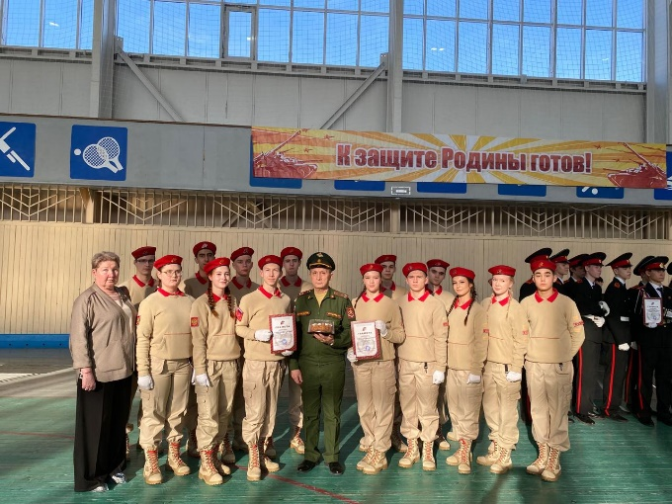  NURGALIEV ILDUS RAVILOVICH AND “PATRIOT” TEAM

school museum

INTERVIEW WITH THE TEACHER OF SOCIAL SCIENCE AND HEAD OF SCHOOL MUSEUM – SULAYMANOVA ELMIRA RAIFOVNA
AUTHOR: Vidyakina Kseniya, Adamkulova Samira, 10B grade  - When was the school museum founded? Who initiated its creation?  - The creation of school museum. At one of the first teacher meetings, in the fall of 1995, the school principal Eduard Vladimirovich Kopvillem called on teachers to resume local history work, to search for the necessary exhibits, photographs, documents, and to involve school students in this. I remember his phrase: "Life confirms that it is impossible to inspire a person to a feat without bowing to a feat that has already been accomplished." This became a kind of slogan of the local history circle, created by the history teacher Fedotov A.N. in the same autumn of 1995. However, they did not start from scratch in the literal sense of the word. Even during the construction of the new school, bulldozers leveled the area around the building. Russian and English-made rifle shells from the First World War, a Russian three-line rifle bolt of the 1891 model, a four-sided bayonet, and shell were left on the surface along with the new layers of earth. So, it was the beginning of our museum's collection.  - How many exhibitions are there in the museum now? What are the most interesting or significant exhibits in the collection?  - There are a lot of exhibits in our museum. The most interesting or significant exhibits I think the expositions of primitive society, coins, a collection of samovars, irons, cameras, tools of peasants, objects of Tatar and Russian everyday life are presented. In the hall of military and labor glory: artifacts from the Civil War, an exposition dedicated to the Great Patriotic War, an exposition dedicated to the Afghan and Chechen wars, a Special Military operation. Another interesting exhibition is dedicated to the heads of the Maysky agro-combine, V.V. Karpov and I.G. Ganiev, the Maysky enterprise itself and the Kazanskaya poultry farm. There is also an exhibition dedicated to the village of Osinovo and the school of S. Osinovo. All of them are dear for me.  - Which exhibit do you personally like the most and why?  - Each exhibit is precious, as it is a piece of a certain era, a piece of someone's life. | - Is there a replenishment of the museum's collections? If so, how often does this happen?  - The collection is constantly being updated. Every year, even several times a year. The state ensures that schools provide students with solid knowledge of the fundamentals of science, teach them how to apply this knowledge in practice, and educate students to be active citizens of modern Russia.  - What role does the museum play in the school's educational program?  - It promotes general education, moral and aesthetic education of students, comprehensive growth and development of their abilities. It educates schoolchildren to love their native land, pride in its past and present - qualities on the basis of which citizenship, patriotism, and pride in their Homeland are formed. School local history has transformed from a methodical technique in our school into a general pedagogical principle, the essence of which is to establish a link between the studied school history course and the knowledge and skills acquired as a result of the study of the native land. This allows the teacher to teach history based on rich concrete material, and allows him to link the general historical patterns of the country's development with the peculiarities of the development of his native land. The first history lesson in 5th grade, I always start with a visit to our museum, you can call it a practical lesson when the children plunge into the past. Here it is easier for children to understand what history is, what historical sources are, that they can be tangible and written. Students can see and touch it with their own eyes. Here, the guys understand that a story is not only a story, but also a study.  - How would you like the information of the school museum to be translated into English?  - I think this should have been done a long time ago. So, it will be possible to conduct excursions in English and practice your knowledge of a foreign language.
OUR VICTORIES

INTERVIEW WITH THE TEACHER OF ENGLISH – POPOVA ELMIRA RINATOVNA
AUTHOR: PUSHILINA LIZA, HOZYASHEVA DARIYA, 1OB GRADE
Naila Fanovna: We have come to interview you and we want to ask some questions about your work and successful students in our school. Now, please, these are our students from English club: Liza and Daria from 10B grade. Are you ready to answer our questions?
Elmira Rinatovna: I’m always ready.
Naila Fanovna: We are happy, please.
Liza: How long have you been working at our school?
Elmira Rinatovna: I have been working here for 10 years
Dariya: How did you decide to become an English teacher?
Elmira Rinatovna: So, I didn’t decide to be an English teacher. What's interesting that I studied French, when I was at school and I wanted to be a teacher of French. But when I ended the university my second language there was English. Now, unfortunately, it is very difficult to find the school with a French language, and that’s why now I’m working as an English teacher and I like it very much.
Liza: That’s interesting. Do you like your profession? What would you recommend to the students who want to take the English exam and follow the path of a teacher or translator?
Elmira Rinatovna: As I have already said I like my profession and I would recommend to my students to go there. One of my students decided to be a teacher of English. She finishes the school this year: Giniyatova Ramilya, she wants to be a teacher of English and I'm proud of this.
Daria: Is it difficult to take English exams?
Elmira Rinatovna: Yes, I think that this exam is very difficult and it’s worth noting that this exam gets more and more difficult. It’s really difficult!
Liza: We know that you have outstanding students who have won prizes in various competitions. How do you manage to motivate your students to participate in Olympiads and conferences?
Elmira Rinatovna: Yes, unfortunately, I have a lot of such students. In order to motivate them I tried to process them that it is necessary not only for me but it is necessary for them. So if you think about your future university and about the necessity to end the university of course it is necessary to participate in different Olympiads and conferences and my students fortunately understand it.
Daria: What achievements of your students can you boast about?
Elmira Rinatovna: I can boast about all achievements of all my students. Really, I have a lot of excellent students, but my best one is Giniyatova Ramilya, she is now in the 11B. I have been working with her for 10 years, I met her first time when she was in the 2 form and now she is my best student, really. She won a lot of Olympiads, conferences, different language competitions and I’m proud of her. But friendly speaking, all my students, that participate in different conferences, they are the best of the best.
Daria: Thank you for participating in our interview, it was very interesting for us to listen to you.

